**Bluetooth-Controlled Home Automation System**

**Objective:**  Design a system to switch home appliances ON/OFF using Bluetooth via a smartphone.

**1. Components Required**

* **Microcontroller:** Arduino UNO REV3
* **Bluetooth Module:** HC-05 (or HC-06)
* **Relay Module:** 4-Channel Relay (5V)
* **Power Supply:** 5V Adapter (for Arduino & Relays)
* **Breadboard & Jumper Wires**
* **Smartphone App:** "Bluetooth Terminal" (e.g., Arduino Bluetooth Controller)
* **Devices to Control:** Bulbs, Fans, etc. (AC/DC)

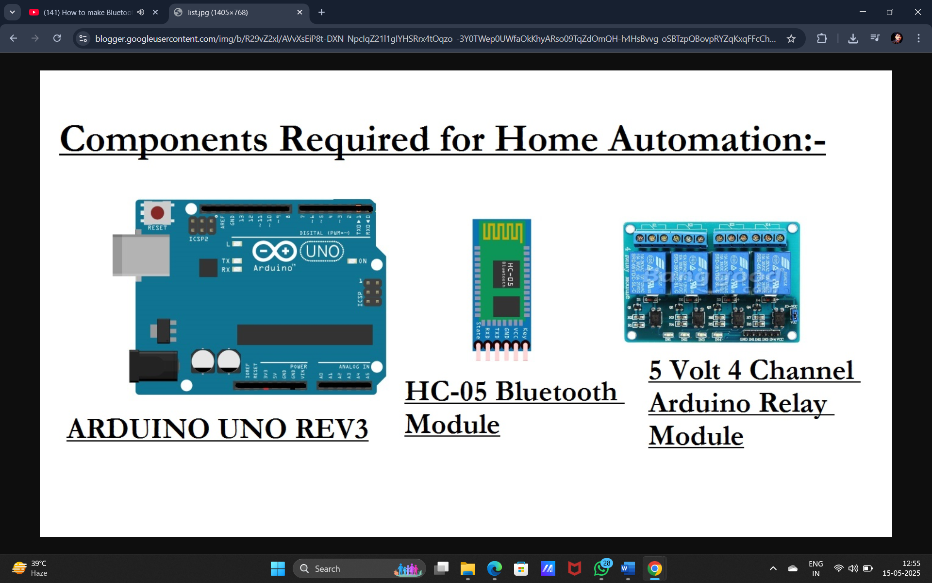

**2. Circuit Diagram**

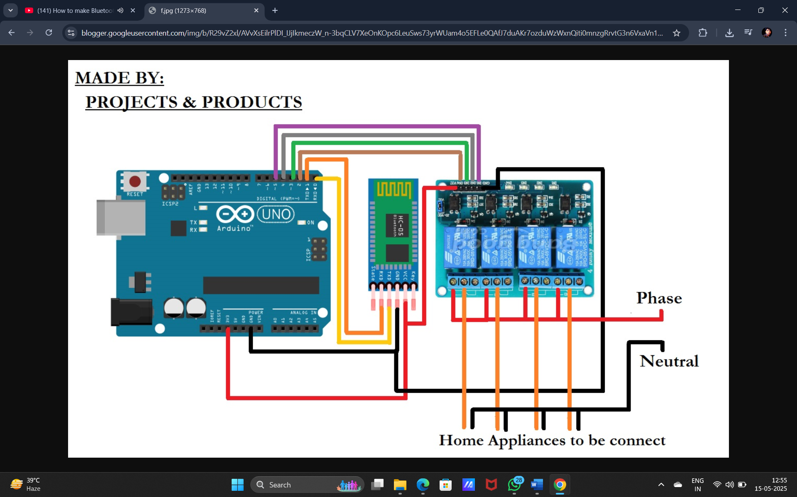

**3. Connections:**

| **Arduino** | **HC-05 Bluetooth** | **Relay Module** |
| --- | --- | --- |
| 5V | VCC | VCC |
| GND | GND | GND |
| TX (Pin 1) | RX | - |
| RX (Pin 0) | TX | - |
| Digital Pins (2,3,4,5) | - | IN1, IN2, IN3, IN4 |

**Note:**

* **For AC Appliances:** Connect relay COM to live wire, NO (Normally Open) to the device.
* **For DC Appliances:** Connect relay COM to power (+), NO to the device.

**4. Working Demo Steps**

**Step 1: Hardware Setup**

1. Connect the HC-05 Bluetooth module to Arduino (5V, GND, TX→RX, RX→TX).
2. Connect relay inputs (IN1-IN4) to Arduino digital pins (2-5).
3. Power the Arduino and relay module.

**Step 2: Upload Code**

* Upload the provided Arduino code via USB.
* Open **Serial Monitor (9600 baud)** to check Bluetooth connection.

**Step 3: Pair Bluetooth & Control Devices**

1. **Pair HC-05** with your smartphone (Default PIN: **1234 or 0000**).
2. Open **Bluetooth Terminal App** (e.g., "Arduino Bluetooth Controller").
3. Send commands:
   * A → Relay 1 ON
   * a → Relay 1 OFF
   * B → Relay 2 ON
   * b → Relay 2 OFF
   * (Similarly for relays 3 & 4)

**Expected Output:**

* When you send A, the corresponding relay activates, turning ON the connected device.
* Sending a turns it OFF.

**5. Enhancements (Optional)**

* **Voice Control:** Use an app like **"Voice Bluetooth Terminal"** for voice commands.
* **WiFi + Bluetooth:** Replace Arduino with **ESP32** for dual control (Bluetooth + WiFi).
* **Automation:** Add sensors (PIR, LDR) for automatic switching.

**Conclusion**

This system provides a **low-cost, wireless** way to control home appliances via Bluetooth. The circuit is simple, and the code can be extended for more devices.